Hong Kong Forum Networking Event in Frankfurt, 1 December

With the end of the Corona pandemic, Hong Kong is back more alive than ever as the main gateway to the Chinese market. On 1 December, Hong Kong trade development Council and BVMW Frankfurt RheinMain have organised the Hong Kong Forum Networking event in Frankfurt Filmmuseum.
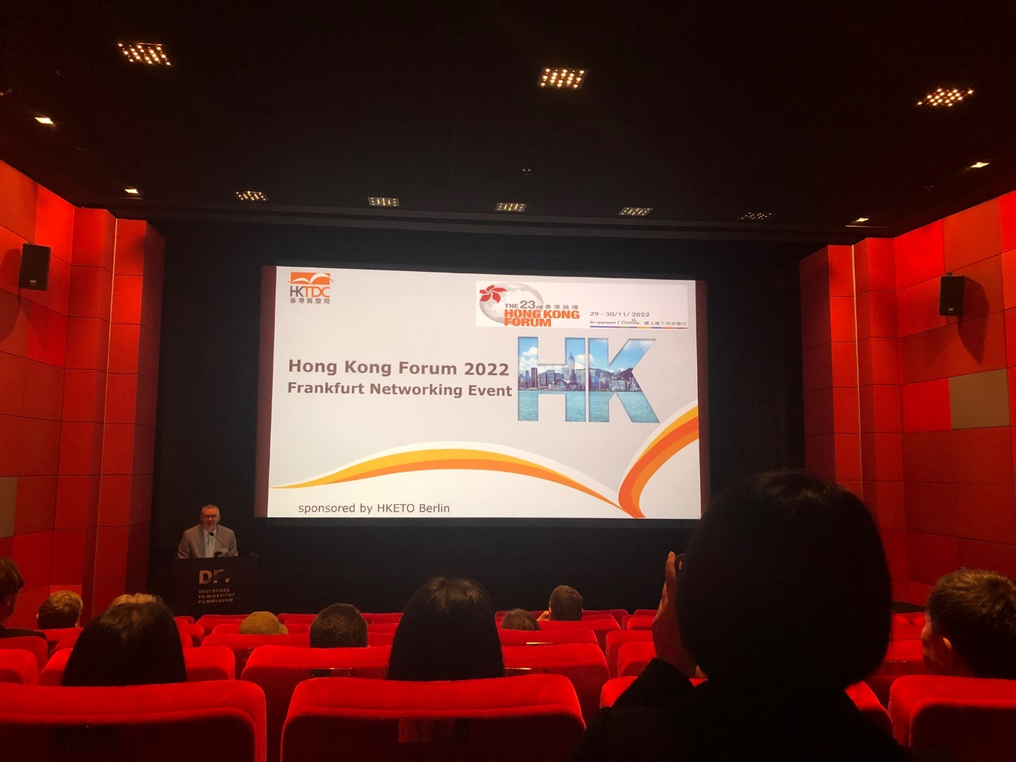
Two experts shared trading insights in their keynote speeches: Alexander Kaymer, Chief representative of BVMW in Hong Kong and Alexander Schultz, Director E-commerce of Melchers Trading Bremen.
The Forum then viewed the recordings of the opening speech by John Lee, the Chief Executive of Hong Kong SAR.
Thanks to all our guests and to our sponsor HKETO Berlin.

